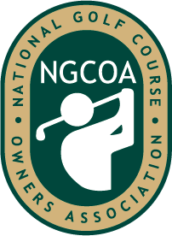

NEGCOA
COURSE OF THE YEAR NOMINATION FORM

Name: __________________________ Course Name: ________________________________

Phone: __________________________ Date: _______________________________________

Email: ___________________________ Web Address: ________________________________

Don’t let modesty prevent you from nominating your own excellent operation. Please provide answers to the following questions. Provide the committee with as much information as possible. It is not intended that you use this page as your application. In fact, if you only submit this page with comments below each answer you are actually hurting your chances for the award. So please, use these questions as a guide for a more professional presentation of your application.

Exceptional quality of the course:

Exceptional quality of ownership and management:

Outstanding contribution to local community:

Significant contribution to the game:

Entries for the 2024 award must be received by Friday, August 18, 2023. In effort to reduce our carbon footprint and for easing sharing with the review committee, applications and course photos must be submitted electronically to Elaine Gebhardt at egebhardt@negcoa.org. Applications may be submitted in a Word or PDF document. Photos are to be in a high-resolution, .jpg format and incorporated into your application document.

*Please note that past winners must wait 7 years before applying again.

